Module 3 Critical Thinking

Nicole Janes

Principles of Programming

Colorado State University-Global Campus

Lori Farr

October 27, 2024

**PART 1**

**Pseudocode**

1. Prompt the user to enter the charge for the food.
2. Calculate the tip amount as 18% of the food charge.
3. Calculate the sales tax amount as 7% of the food charge.
4. Calculate the total amount by adding the food charge, tip, and tax.
5. Display the food charge, tip amount, tax amount, and total amount.

**Source Code**

>>> food_charge = float(input("Enter the charge for the food: "))

Enter the charge for the food: 100.00

>>> tip = food_charge * 0.18

>>> tax = food_charge * 0.07

>>> total_amount = food_charge + tip + tax

>>> print(f"Food Charge: ${food_charge:.2f}")

Food Charge: $100.00

>>> print(f"Tip Amount (18%): ${tip:.2f}")

Tip Amount (18%): $18.00

>>> print(f"Sales Tax (7%): ${tax:.2f}")

Sales Tax (7%): $7.00

>>> print(f"Total Amount: ${total_amount:.2f}")

Total Amount: $125.00

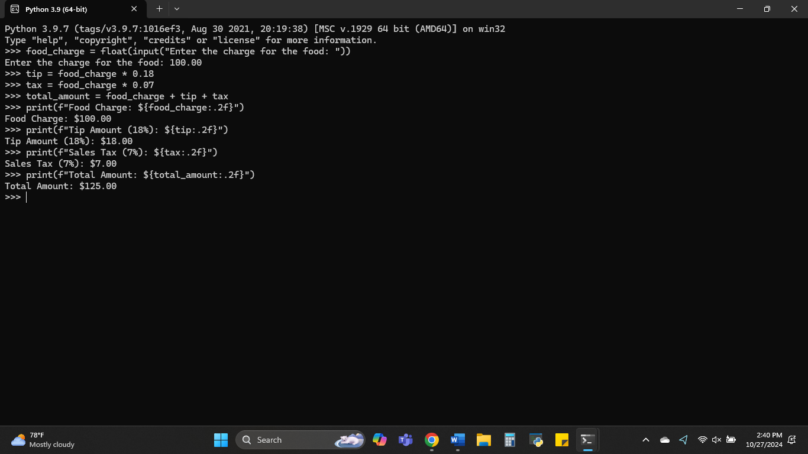

**PART 2**

**Pseudocode**

1. Prompt the user to enter the current time (in hours, 0-23).
2. Prompt the user to enter the number of hours to wait for the alarm.
3. Calculate the alarm time by adding the current time and the wait time, then take the result modulo 24.
4. Display the resulting time when the alarm will go off.

**Source Code**

>>> current_time = int(input("Enter the current time (in 24-hour format, 0-23): "))

Enter the current time (in 24-hour format, 0-23): 20

>>> wait_hours = int(input("Enter the number of hours to wait for the alarm: "))

Enter the number of hours to wait for the alarm: 5

>>> alarm_time = (current_time + wait_hours) % 24

>>> print(f"The alarm will go off at: {alarm_time:02d}:00")

The alarm will go off at: 01:00